

**Project Report on**

# College Event Management System

**Submitted For Partial Fulfil Towards the Degree Of**

**BACHELOR OF COMPUTER APPLICATION [BCA]**

**YEAR: 2024-2025**

**Submitted To:**

**M.K. INSTITUE OF COMPUTER STUDIES, BHARUCH**



**Submitted By:**

**Panchal Vaidehi Sanjaybhai**

**Exam Seat No: 1896**

**Internal Guide:**

**Meghna Vithlani**

***Certificate***

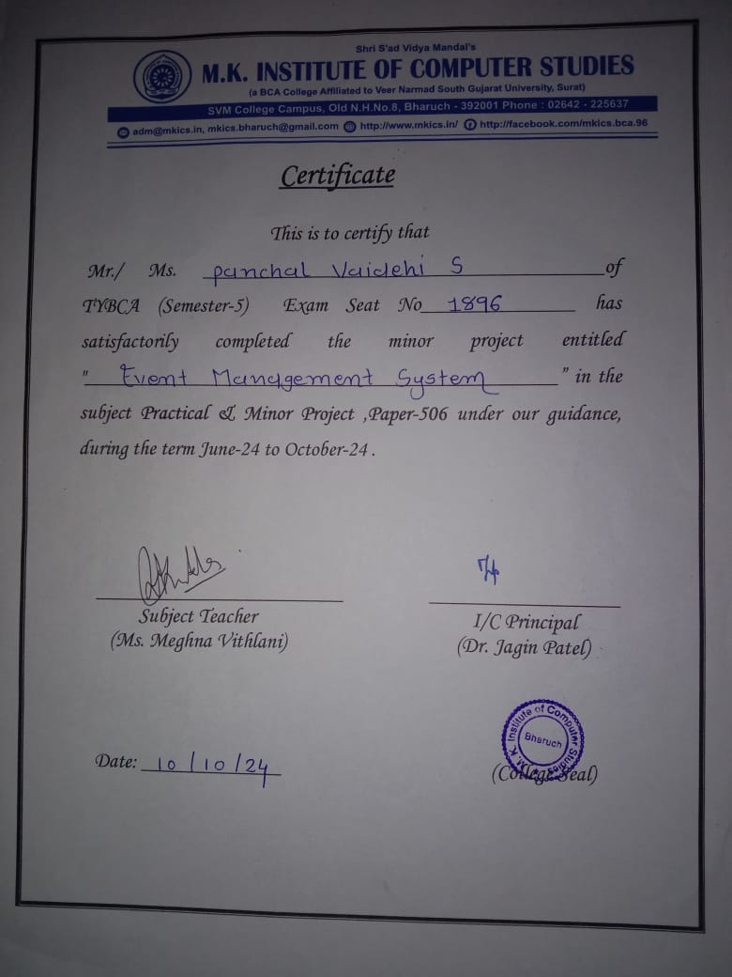

***Index***

|  |  |  |
| --- | --- | --- |
| **No.** | **Title** | **Page No** |
| 1 | Project Profile | 3 |
| 2 | Project Introduction | 4 |
| 3 | Scope And Objective | 5 |
| 4 | Tools And Technologies | 6 |
| 5 | Table Design | 7 |
| 6 | DFD | 10 |
| 7 | System Module | 17 |
| 8 | Screenshots | 18 |
| 9 | Future Enhancement | 29 |

**1.0 Project Profile**

|  |  |
| --- | --- |
| **Project Name :** | Event Management System |
| **Developed By :** | Panchal Vaidehi Sanjaybhai  22B055 |
| **College Details :** | Name : M. K. Institute of computer studies  Address : Old NH-8,College Campus,  Bharuch  Phone : 02642 225637  Email-id : mkinstitute@gmail.com  Website : [**www.mkics.in**](http://www.mkics.in/) |
| **Internal Guide :** | Meghna Vithlani |
| **Front End :** | Html, Bootstrap 4, JQuery, CSS |
| **Back End :** | MySql |
| **Server Side Scripting language:** | PHP |

# 2.0 Project Introduction

* The *College Event Management System* is designed to streamline the organization and management of events within a college environment.
* Managing various events such as seminars, cultural fests, workshops, and sports activities can be challenging and time-consuming without an efficient system.  
  This system aims to simplify event planning, registration, and communication between event organizers and participants.
* By leveraging a web-based platform, it provides a seamless solution for students, faculty, and administration to manage college events efficiently.

## 2.1 Project Definition

* The *College Event Management System* is a web-based platform designed to facilitate the efficient planning, organization, and management of college events. It allows users to register for events, view event details, and communicate with event organizers, ensuring smooth coordination between participants and administrators.

***3.0 Scope And Objective***

**3.1 Scope**

## Scope for admin

* Create event login
* View user details
* Update and delete any user details
* View all event details
* Update and delete any event details
* View user wise, event wise and booking event report
* View feedback
* View user event bookings

## Scope for Users

* Login Username And Password
* Give a feedback
* Book event as per user requirements
* View its own booking
* View and update profile

### 3.2 Objective

* The objective of the *College Event Management System* is to provide a user-friendly platform for efficient event management, enabling seamless coordination, registration, and communication between students, faculty, and event organizers within the college.

# 

# 4.Tools And Technologies

## 4.1 System Technologies

* Html
* CSS
* JavaScript
* JQuery 3.1
* Bootstrap 5
* PHP 7.4.26
* AngularJS

**4.2 Tool For Used To Development**

* Visual studios

## 4.3 Software Requirements

* Back End : MySql 5.7.36 , PhpMyAdmin 5.1.1, Apache 2.4.51,WampServer 3.2.6 - 64bit
* Operating System : Windows 10 And windows 11
* Browser Supports : Google Chrome, Microsoft Edge

# 

# 

# 

# 5.Table Design

|  |  |  |  |
| --- | --- | --- | --- |
| **Table Name** | admin_master | | |
| **Description** | This table provide the information about admin | | |
| **Field Name** | **Data type** | **Constraints** |
| admin_Id | Int | Primary Key |
| admin_name | Varchar (100) | Not Null |
| admin_Password | Varchar (100) | Not Null |

|  |  |  |
| --- | --- | --- |
| **Table Name** | event_master | |
| **Description** | This table provide the information about event | |
| **Field Name** | **Data type** | **Constraints** | |
| event_id | Int | Primary Key | |
| event_name | Varchar (100) | Not Null | |
| event_description | Varchar (100) | Not Null | |
| event_date | Date/Time | Not Null | |
| event_location | Varchar (100) | Not Null | |
| event_time | Date/Time | Not Null | |
| event_charges | Varchar (100) | Not Null | |
|  |  |  | |

## 

|  |  |  |
| --- | --- | --- |
| **Table Name** | feedback_website | |
| **Description** | This table provide the information about feedback | |
| **Field Name** | **Data type** | **Constraints** |
| f_id | Int | Primary Key |
| user_id | Int | Not Null |
| Message | Varchar (100) | Not Null |
| Email | Varchar (100) | Not Null |

|  |  |  |
| --- | --- | --- |
| **Table Name** | participate_master | |
| **Description** | This table provide the information about participate | |
| **Field Name** | **Data type (Size)** | **Constraints** |
| participate_id | Int | Primary Key |
| event_id | Int | Not Null |
| User_id | Int | Not Null |
| participation_status | Varchar (100) | Not Null |
| p_name | Varchar (100) | Not Null |
| Status | Int | Not Null |

|  |  |  |
| --- | --- | --- |
| **Table Name** | user_master | |
| **Description** | This table provide the information about user | |
| **Field Name** | **Data type** | **Constraints** |
| user_id | Int | Primary Key |
| user_name | Varchar (100) | Not Null |
| user_email | Varchar (100) | Not Null |
| user_password | Varchar (100) | Not Null |
| user_address | Varchar (100) | Not Null |
| user_age | Varchar (100) | Not Null |

|  |  |  |  |
| --- | --- | --- | --- |
| **Table Name** | | audience | |
| **Description** | | This table provide the information about audience bookig | |
| **Field Name** | **Data type** | | **Constraints** |
| a_id | Int | | Primary Key |
| event_id | Int | | Not Null |
| Name | Varchar (100) | | Not Null |
| Address | Varchar (100) | | Not Null |
| phone number | Int | | Not Null |
| Members | Varchar (100) | | Not Null |

## 6. DFD(Data Flow Diagram)

**Definition**

Data flow is a network diagram illustrating a computerized system, manual or a combination of both, and representation in the form of a set of structured system components that are interconnected in accordance with the rules play. Advantages of DFD is possible to describe the system from the highest level and then them into a lower level (decomposition), whereas the lack of the DFD does not indicate the process is looping, decision-making process and the process of calculation.



**Data Flow Diagram Sym**

**bols**

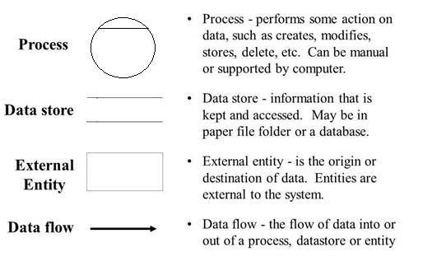

Context Level DFD

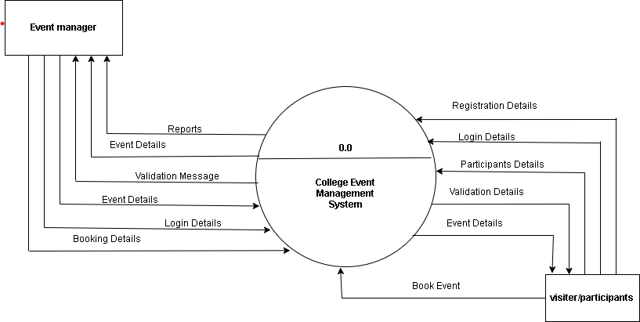

***1ST LEVEL DFD FOR USER***

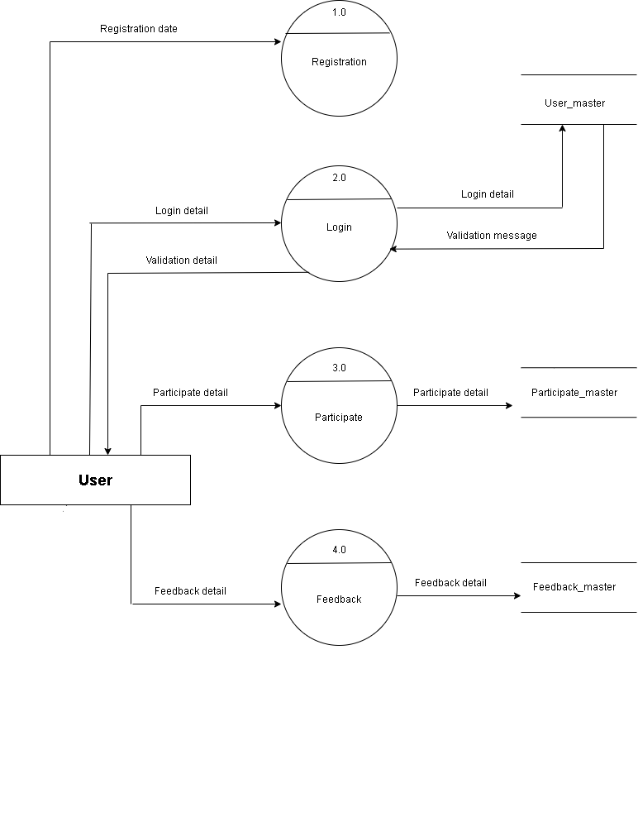

### *1ST LEVEL DFD FOR ADMIN*

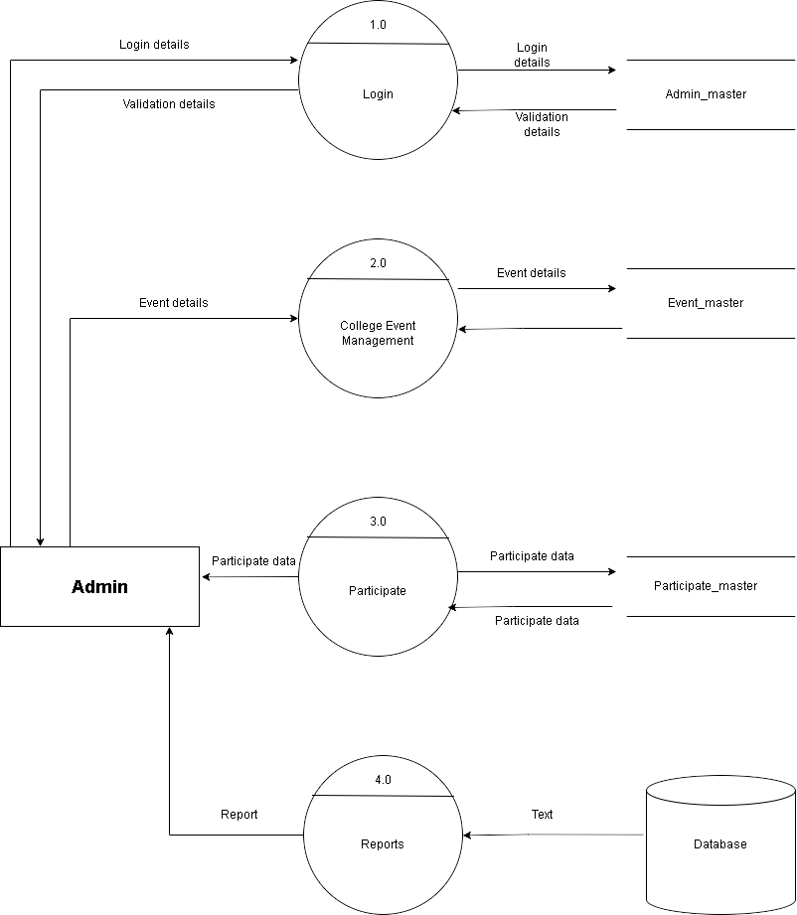

***7. System Module***

**There are two modules:**

1)Admin 2)User

### Functionalities

#### Admin Module

* login.
* view users , remove them and update them.
* add new event , update event and remove event.
* view user wise bookings.
* view feedback.
* generate reports.

**There 4 type of reports:**

1)User wise report.

2)Event wise report.

3)All participate report.

4)Date wise booking report.

#### User Module

* login.
* search event .
* book more than one events according its requirements.
* view booked event and cancel event.
* give a feedback.
* view its own profile and update profile.

#### Admin Module

* login here.
* view participate list.
* view and update profile,

## 8. Screenshots

**User Side:**

User Index– Only user can see this index page

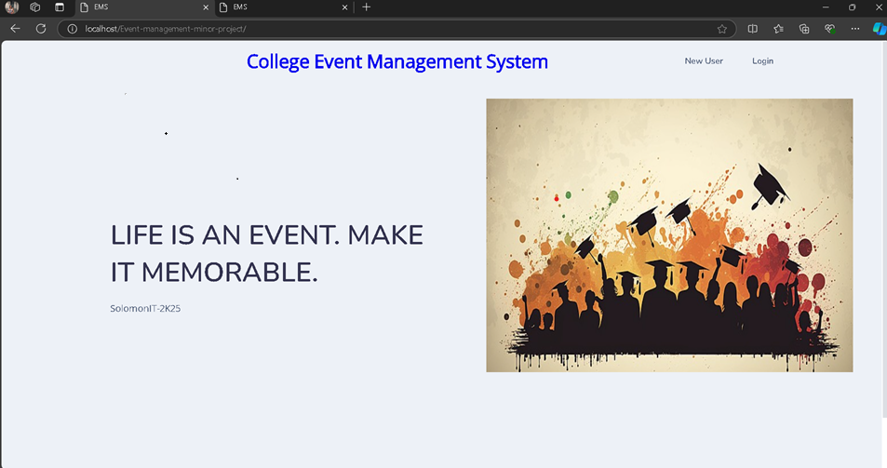

New User

Registration – New user can first time visit this website, it’s compulsory to register this form.

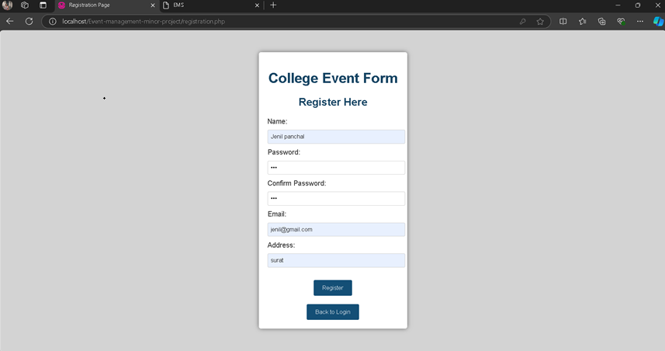

User Login – User can login their email and password which was registered on registration form.

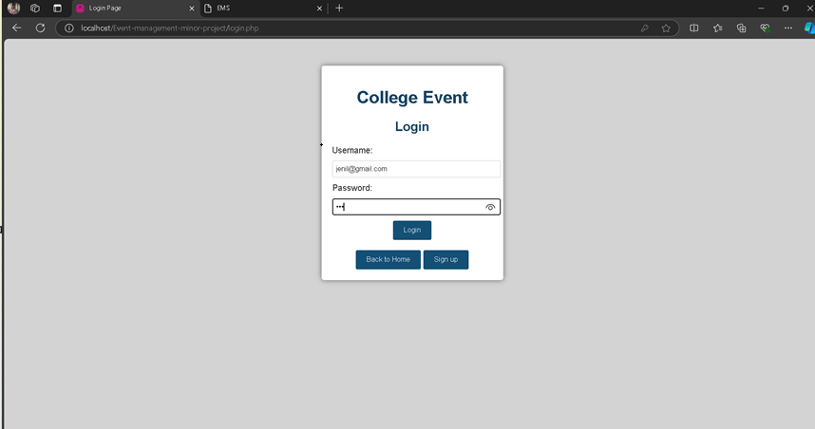

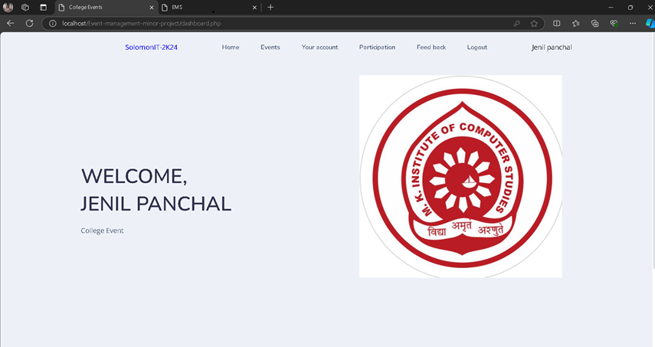 Dashboard – User can see this page after then they logged in to the system.

Events – Only user can see this event page here.

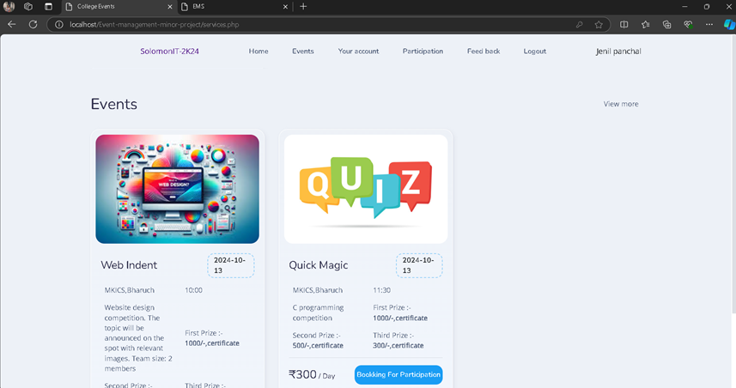

Booking For Participation – User can participate particular event, which they want to part.

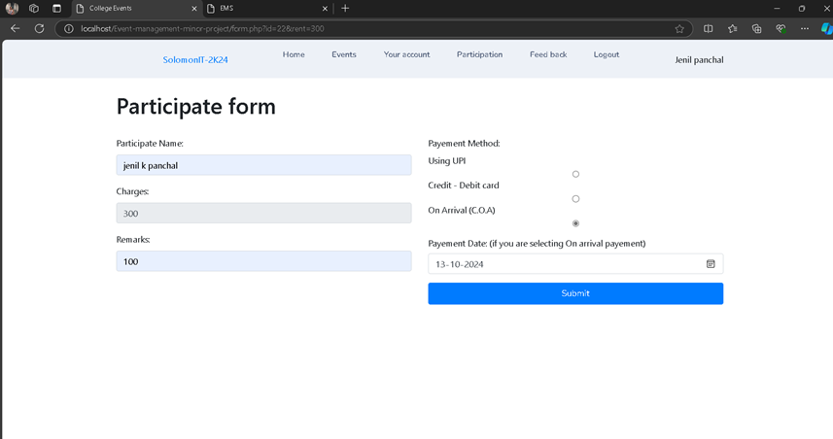

Profile & Participation List – User can see their profile here, also check or manage their participate details.

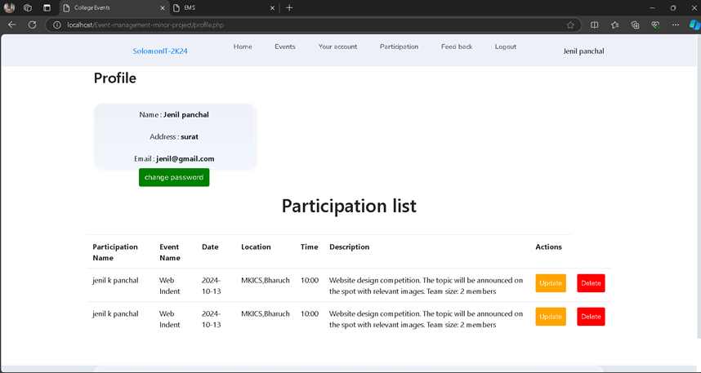

Event Wise Participation Reports – User can see their profile here, also check or manage their participate details.

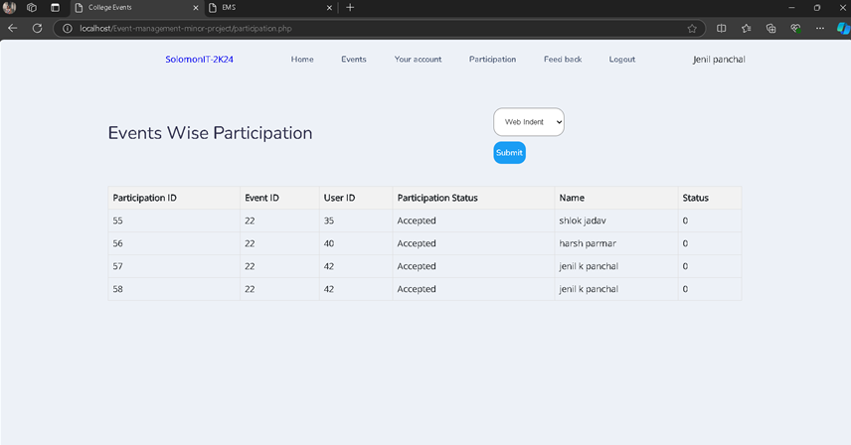

Insert Feedback– User can insert feedback here their own experience.

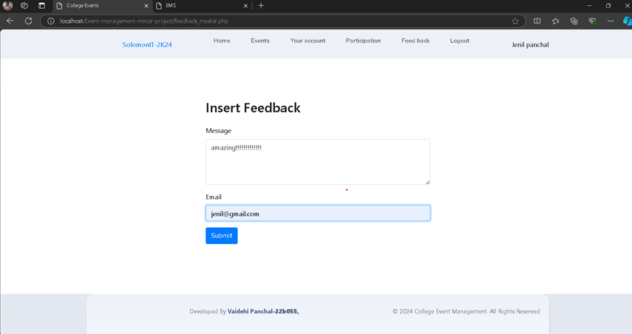

Logout– User can click on logout then user leave this system.

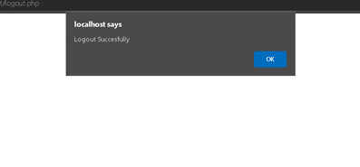

**Admin Module:**

Admin Index– Only admin can see this page.

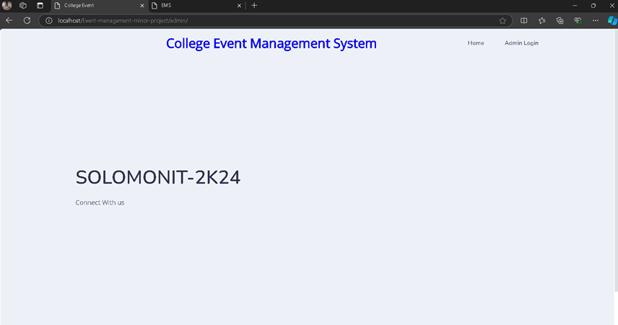

Admin Login – Only admin can login here.

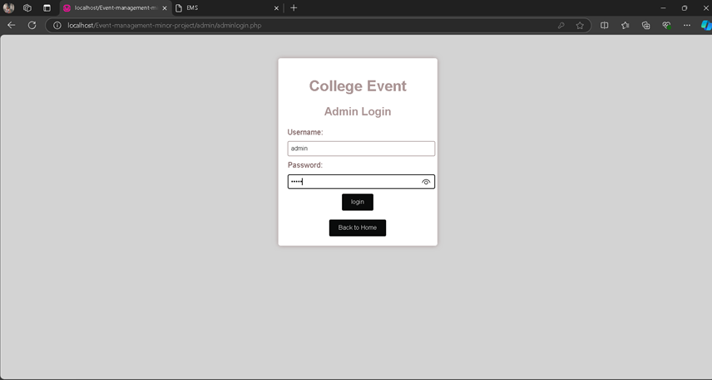

Admin Dashboard – Only admin can see this page after then they logged in to the system.

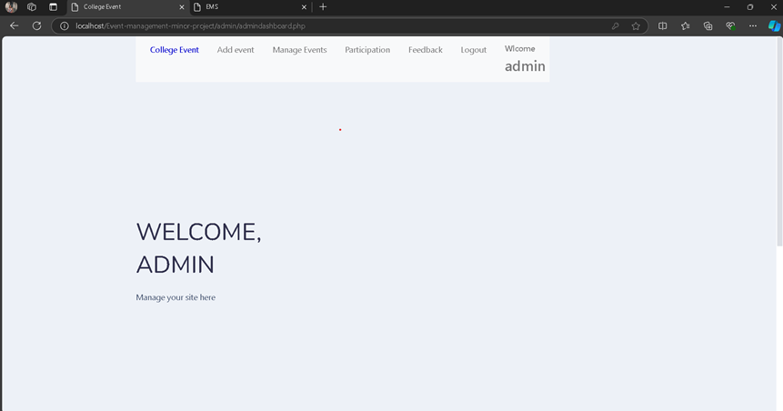

Add Event – Only admin can add new event here.

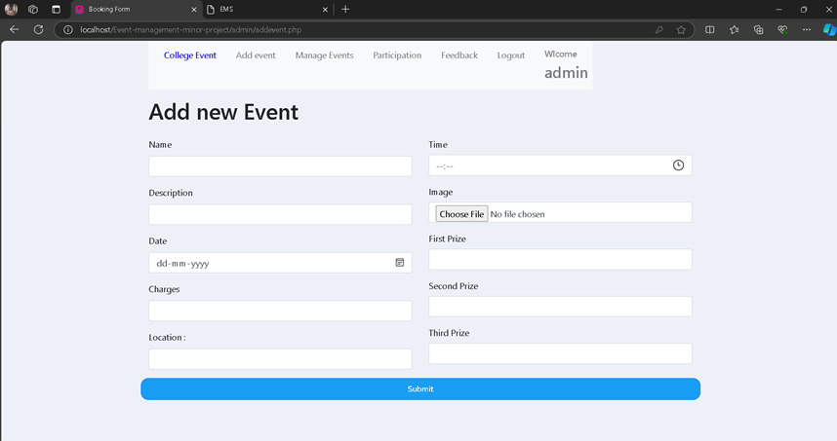

Update event – only admin can change and manage event.

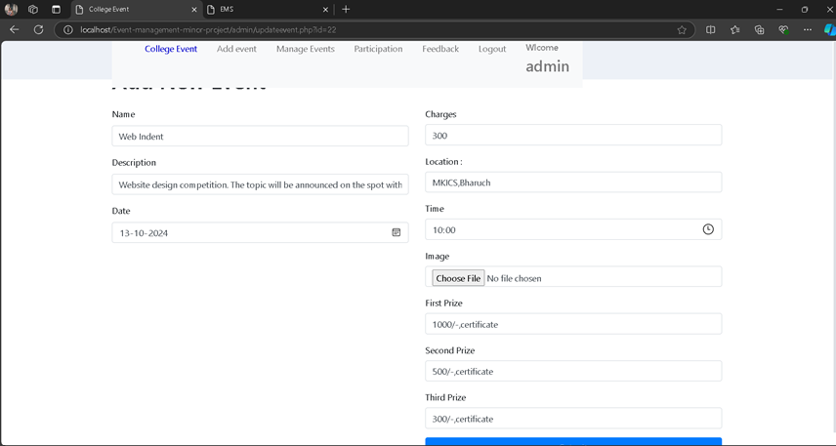

Manage Events (Date Wise Event Report) – Only admin can manage events here.

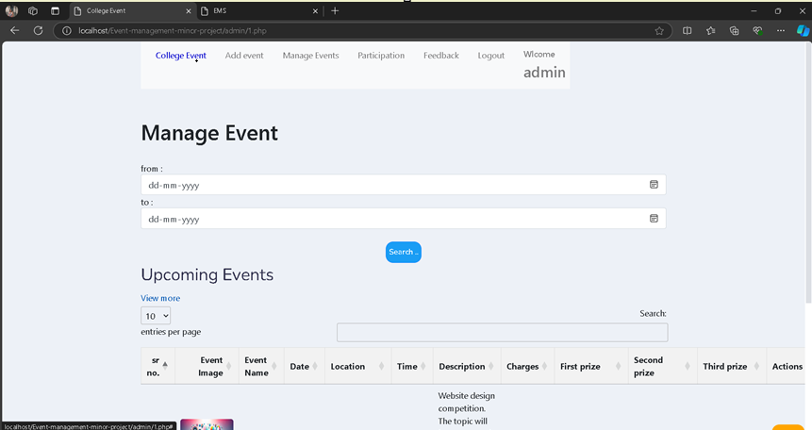

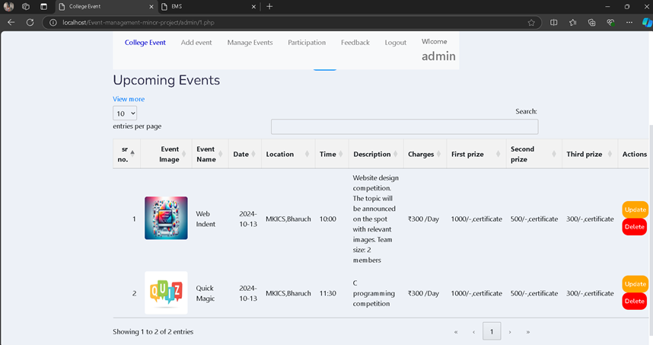

Participate list – only admin can see this page

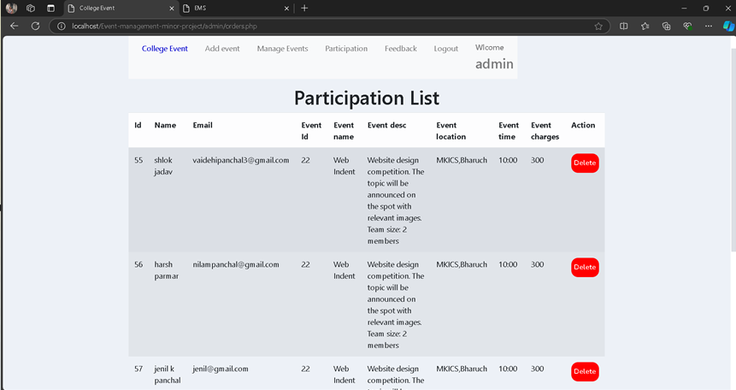

Feedback – only admin can see this page.

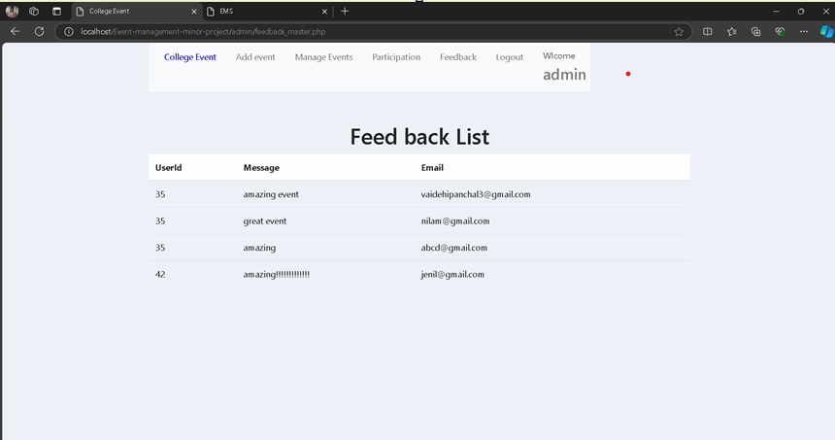

Logout **-**

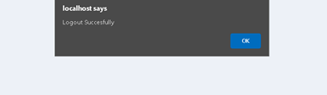

***9. Future Enhancement***

In Future This Web Application will be serving as a complete service to user that include following feature.

* Online Payment Will Be available.

* User Will Be Able To Change Password Using OTP.

* User will get a payment receipt.
* More security will be provided.